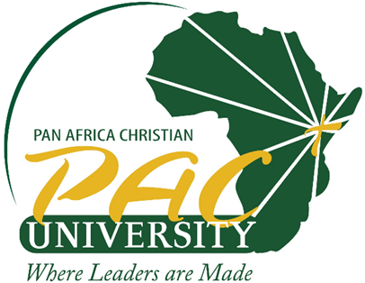

PAN AFRICA CHRISTIAN UNIVERSITY
SCHOOL OF HUMANITIES AND SOCIAL SCIENCES
END OF SEMESTER EXAMINATION FOR THE DEGREE OF MASTER OF ARTS IN COMMUNITY DEVELOPMENT AND SOCIAL PROTECTION
MAY-AUGUST 2023 TRIMESTER
CAMPUS: ROYSAMBU
DEPARTMENT: COMMUNITY DEVELOPMENT
COURSE CODE: MCS 502
COURSE TITLE: FUNDAMENTALS OF COMMUNITY DEVELOPMENT
EXAM DATE:
DURATION: 3 HOURS
TIME: 5:30PM-8:30PM
INSTRUCTIONS
➢ Read the instructions and questions carefully before you write the answers.
➢ Answer any TWO questions
➢ ALL PAC University’s examination rules and regulations apply

Question one

Justify this statement, Community development is not community development without peoples participation’’ (20 marks)

Question two

a) Examine any two Community development approaches you would use while engaging communities in community development initiatives. Stating their pro and cons. (8 marks)
b) Citing relevant examples, explain any six theories that inform community development practice. (12 marks)

Question three

a) Using relevant examples, explain any five methods of community development you would use in achieving successful Community Development initiatives. (10 marks)
b) Justify the phrase, “There is no “recipe” for a process of community development.” with reference to the key principles that guide a flexible process of engagement and action. (10 marks)

